Carousell Dispute Agent: Business Case
Oct 31, 2026 · @Jonathan
An AI agent that helps Carousell's support staff settle "significantly not as described" disputes is worth about S$400,000 a year in Singapore in our base case (range S$71,000 to S$2.0 million). Most of that value comes from trust: fairer, faster disputes keep buyers on the protected 'Buy' button. Staff time saved is the smaller part.

The problem in numbers
Carousell is Singapore's biggest scam channel for online shopping, and most of those scams happen when buyers pay outside the protected 'Buy' button. Every figure below comes from a page we opened, except where marked.
Fact | Figure | Source
Carousell's share of Singapore e-commerce scam cases, 2025 | 29.0% of 6,703 cases (about 1,940) | SPF brief 2025
How those victims paid | "PayNow or bank transfer", outside the 'Buy' button | SPF brief 2025
Money lost to e-commerce scams, 2025 (all platforms) | S$16.7 million | SPF brief 2025
E-commerce scam cases, first half of 2026 | 3,865, up 19.3%; Carousell had the most | ScamShield ESSR 1H 2026
Suspicious accounts Carousell suspended in Singapore, 2025 | 52,000+ | Carousell scam report 2025
Community reports Carousell reviewed in Singapore, 2025 | 78,000+ | Carousell scam report 2025
Singapore transactions with no recorded scam, 2025 | 99.97% | Carousell scam report 2025
Transactions that raised a dispute at Mercari Japan, a similar marketplace | 0.40% in the first half of 2025, down from 0.56% in late 2023 | Mercari transparency report
Mercari compensations completed within 48 hours | 93% | Mercari transparency report
Platform fee Carousell charges buyers on Buyer Protection listings | 3.5% to 6% of the item price (search result; check by hand) | Carousell SG fees
Median gross wage, customer service officer at a firm of 200+ staff, June 2025 | S$3,362 a month | MOM wage tables 2025
Carousell Group revenue, FY25 | $141 million, up 18% | Carousell FY25 results
Carousell does not publish how many disputes it handles, so the dispute volume below is our estimate.

Why it matters to Carousell
Buyer Protection only pays off if buyers trust it, and that trust is built or lost when a dispute is settled.
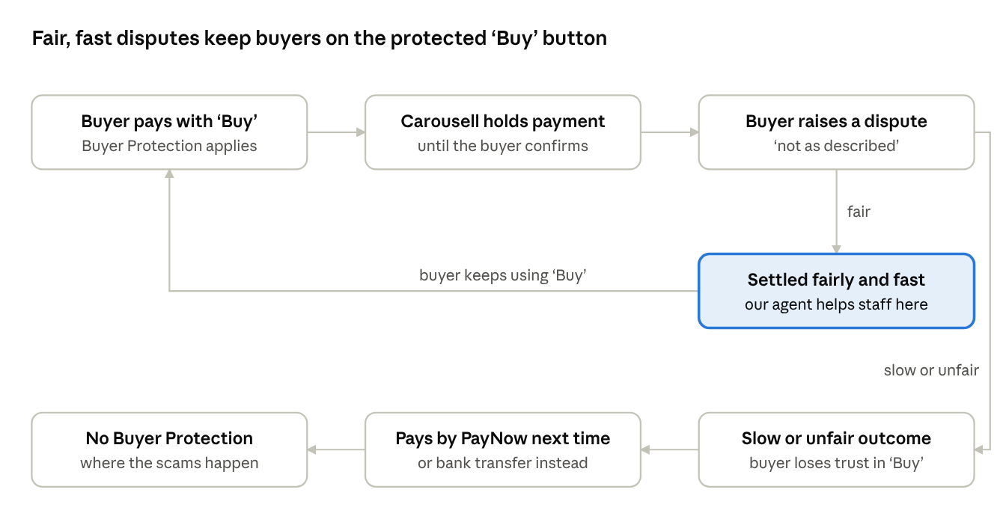
dispute outcome and buyer trust · 2 paths
This is our argument, not a measured effect. A fair, fast decision keeps the buyer on the 'Buy' button. A slow or unfair one pushes them to PayNow or bank transfer, which is how 2025's Carousell scam victims paid (SPF brief 2025).

Value to Carousell
In the base case the agent is worth about S$400,000 a year in Singapore: S$80,000 of staff time plus S$320,000 of extra platform fees.
Annual value = (disputes per year × staff hours saved per dispute × cost per staff hour) + value of more ‘Buy’ button deals
Result per year (Singapore) | Low | Base | High
Orders paid with the 'Buy' button | 1.2M | 2.4M | 4.0M
Disputes | 4,800 | 12,000 | 40,000
Disputes escalated to Carousell staff | 1,440 | 6,000 | 28,000
Staff hours saved | 290 | 2,250 | 16,800
Staff time saved (term 1) | S$8,000 | S$80,000 | S$756,000
Extra 'Buy' button deals (term 2) | S$63,000 | S$320,000 | S$1,200,000
Annual value | S$71,000 | S$400,000 | S$2.0M
The case rests on trust, not staff time. In the base case the staff time saved equals about 1.3 full-time staff. Each percentage point of Carousell deals that moves onto the 'Buy' button is worth about S$320,000 a year in fees.
One escalated dispute costs about S$27 of staff time (45 minutes at S$35 an hour). That equals the platform fee on about seven S$100 orders. The agent itself should cost a few cents of AI usage per case; we will measure this in the prototype.
Scale: Buyer Protection also runs in Hong Kong, Malaysia, Taiwan and Vietnam (fact sheet), so the regional value is higher. We have not sized those markets.

Inputs and assumptions
Four inputs come from sources, one is derived, and five are our own assumptions; each has a low, base and high value. If anyone finds a better figure, change it here and the results above.
Input | Low | Base | High | Type | Basis
Carousell transactions in Singapore per year | 6M | 8M | 10M | Derived | Police scam counts divided by Carousell's scam rate (next section)
Share paid with the 'Buy' button | 20% | 30% | 40% | Assumption | Delivery and digital orders must use 'Buy'; meet-ups can pay in person (safety policy, search result)
'Buy' orders that raise a dispute | 0.4% | 0.5% | 1.0% | Sourced | Mercari Japan: 0.40% to 0.56%. The high case allows for vaguer used-goods listings on Carousell
Disputes escalated to Carousell staff | 30% | 50% | 70% | Assumption | The rest are settled between buyer and seller
Staff time per escalated dispute | 30 min | 45 min | 60 min | Sourced | Vendor estimates for manual dispute review: 30 to 60 minutes a case (Chargeflow, search result)
Staff time the agent saves | 40% | 50% | 60% | Assumption | We can measure this in our demo: time per case with and without the agent's draft
Cost per staff hour | S$26 | S$35 | S$45 | Sourced | MOM median S$3,362 a month. Low adds 17% employer CPF over 1,800 working hours; base also adds a 13th month and 25% overheads; high assumes a senior specialist
Average 'Buy' order value | S$60 | S$100 | S$120 | Assumption | No public figure
Platform fee on 'Buy' orders | 3.5% | 4% | 5% | Sourced | Carousell's buyer fee tiers of 3.5% to 6% (search result; check by hand)
Extra deals moved onto 'Buy' | +0.5 pt | +1 pt | +2 pts | Assumption | Deals that switch to the protected flow because disputes are fairer and faster
Sense check: the base case implies S$9.6M a year of 'Buy' button fees in Singapore. That is about 5 to 7% of Carousell Group's FY25 revenue across seven markets, which is plausible. The high case implies S$24M, so treat it as an upper bound.

How we estimated Carousell's transaction volume
Carousell does not publish its transaction count, but two public figures let us estimate it at roughly 6.5 to 9.6 million a year in Singapore.
- Carousell says 99.97% of Singapore transactions in 2025 had no recorded scam, so 0.03% did. Its report defines this as "recorded scam cases out of total transactions" (Carousell scam report 2025).
- The police count about 1,940 Carousell e-commerce scams in 2025 (29.0% of 6,703). Counting every scam where the scammer made contact on Carousell gives about 2,870 (75.5% of 3,804 online-shopping-platform cases) (SPF brief 2025).
- 1,940 ÷ 0.03% ≈ 6.5 million and 2,870 ÷ 0.03% ≈ 9.6 million transactions. We use 8 million as the base case.
This is an order-of-magnitude estimate. Carousell's own scam count may differ from the police count, and 99.97% is rounded.

Limits and what to check before presenting
The weakest link is the jump from fairer disputes to more 'Buy' button deals: it is our argument, not a measured effect.
- Check by hand: Carousell's help pages block automated reading. Open the fees page and the safety policy in a browser and confirm the 3.5% to 6% fee and the rule that delivery orders must use 'Buy'.
- Vendor figure: the 30 to 60 minutes per dispute comes from a company selling dispute automation. Our demo can replace it with our own timing.
- Scams are not disputes: most scams happen outside Buyer Protection, so the agent does not stop scams directly. It makes the protected flow more worth using.
- Carousell may build it itself: its fact sheet says it already applies AI to "customer support workflows". Pitch the agent as a tool Carousell builds or licenses, not as something it lacks entirely.
- Currency: Carousell reports revenue as "$141 million" without naming the currency. We assume US dollars; that only affects the sense check.

Lines for the slides and video
Use these as the business half of the pitch; each line has its source above.
- Problem: "Carousell was behind 29% of Singapore's e-commerce scam cases in 2025, and the victims paid by PayNow or bank transfer, outside the protected 'Buy' button."
- Why disputes matter: "Buyer Protection only works if buyers trust it. That trust depends on settling 'not as described' disputes fairly and fast."
- Benchmark: "Mercari, a similar marketplace in Japan, cut its dispute rate from 0.56% to 0.40% and now pays out 93% of compensations within 48 hours."
- Value: "We estimate the agent is worth about S$400,000 a year in Singapore alone: S$80,000 of staff time and S$320,000 of extra fees if one more deal in a hundred moves onto the 'Buy' button."
- Honest limit: "Carousell does not publish its dispute numbers, so these are estimates with a low and a high case: S$71,000 to S$2 million."

Sources
Opened and read on 31 Oct 2026, except the three marked as search results.
- SPF: Annual Scams and Cybercrime Brief 2025 (PDF)
- ScamShield: E-Commerce Scams Situation Report 1H 2026
- Carousell: Regional Scam Trends Report 2025, press release
- Carousell: Regional Scam Trends Report 2025, full report (PDF)
- Carousell: FY25 results
- Carousell: fact sheet
- Mercari: Transparency Report, first half of 2025 (PDF)
- MOM: Occupational Wages Tables 2025
- Carousell SG: What are the fees charged to buyers? (search result)
- Carousell SG: Safety policy (search result)
- Chargeflow: cost of manual vs automated chargeback processing (search result)

